American Government and Economics
2017-2018
Room 125

Teacher: Jamie Franz Email: jfranz@mvcsd.us Phone: (740) 393-5900 ext. 5628

Course Description: This course will examine how the American people govern themselves at national, state and local levels of government. We will be breaking each of these levels down and studying their impact on you as citizens of the United States. Students will study major economics concepts and issues, and the application of previously acquired skills and knowledge. Students will impact issues addressed by local governments through service learning projects.

Classroom Rules and Expectations:
Rule: | Explanation:
Be respectful to yourself and others | In this classroom respect each other’s physical space along with their individual thoughts/ ideas.
Stay on task and apply yourself. | Follow directions, stay focused, and do your best.
Come to class on time, prepared with mind and material | Be in seat when the bell rings with all the material you need and be ready to learn.  - Pencil, homework, chromebook  - NO backpack
Consequences:
If the rules listed above are broken the following consequences will be made. (Please note the order can change due to severity of issue)
1st-Verbal warning/ See me after class
2nd -Call home to parent/guardian
3rd -Detention/ Friday School
4th-Office Referral

Classroom Materials:
- 1- 1” 3-ring binder/folder
- 1- College-ruled notebook (Can be part of a 5 subject notebook)
- Chromebook (bring everyday)
Classroom Procedure:
Class Requirements:
First Nine Weeks: 2 page APA paper
-Focus on writing skills
Second Nine Weeks: 2 page APA paper
-Focus on sources
Third Nine Weeks: 4-5 page APA paper
- Focus on writing skills and sources
- Can you present and defend argument
Fourth Nine Weeks: Community Service
- Time proved for you to give back to the community
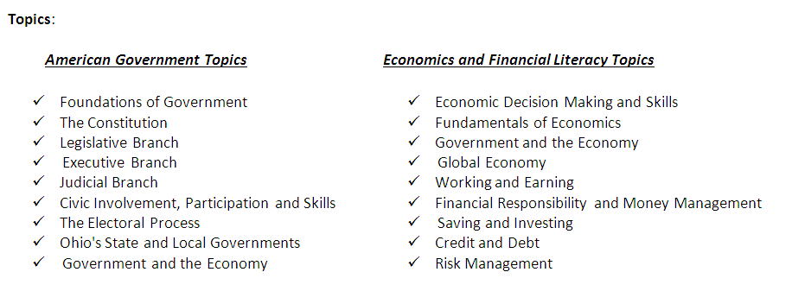

NOTE: Time spent on a particular topic, as well as topic order, may vary as needed.

Discussion/ Debates:
- This is a class that is based around the ideas and philosophy of others, so it is very important that we understand that this classroom is a safe zone. We understand that each person is entitled to their own opinion, and that it may not be the same as our own, but we can respect it anyways. We also raise our hand to ask a question or to contribute to a discussion.
There will be zero tolerance on put downs towards others.

Assignments:
Assignments should be turned into the correct bin (numbered for each class period) in colored folder in each bin. You may turn in late work for half credit up until the end of unit to turn in work. After we take the chapter test and/or project work from that unit will not be accepted. Please keep in mind that some points are better than no points!

Attendance/ Tardy:
- It is up to you to get your late work, meaning you need to ask for your assignments and/or schedule when you are going to make up your Test or Quiz. Failure to do so could result in a zero on assignments.
- If you have an excused absence from class, you can make up any work from the day you missed and turn it in the following day. You have the number of days that you missed to turn your work without losing any points. For example, if you miss two days in a row, then you have two days to make up the work for full credit.
- If you are more than 10 minutes late to class is counts as an absence to my class. Make sure you are on time.
- If you do not come to class with all materials and ready for instruction and have to leave the room, it counts as a tardy. Examples: If you do not bring your supplies to class and have to go to your locker to get it that counts as a tardy. If you bring a backpack to class and have take it back to your locker that counts as a tardy.

Extra Resources:
My classroom relies a lot on technology. Your Chromebook will be where you will find the resources that you need, like your textbook. Textbooks will not be assigned to take home, homework will use the online book or provided online resources. We will also be using Schoology.com, for assessments (Tests and Quizzes), and Google Classroom for a lot of your assignments. Please write down all of these passwords in your agenda.

Google Classroom: Schoology:
- Online copy of syllabus *Tests
- Worksheets and assignments *Quizzes
- Textbook audio files
- Additional videos or documents

Mrs. Franz Daily Schedule: If you have questions about your assignments or need to schedule a conference please reference the schedule below.
Period | Time | Class
1 | 7:45-8:31 | American Government
2 | 8:35-9:21 | Study Hall (Mon & Wed)
3 | 9:25-10:11 | U.S. History
4 | 10:15-11:01 | Conference
5 | 11:05-11:51 | U.S. History
6 | 11:55-12:25 | Lunch
7 | 12:29-1:15 | World History
8 | 1:19-2:05 | American Government
HIVE | 2:09-2:35 | Group Study
Content Standards for American Government
- TOPIC: CIVIC INVOLVEMENT
1. Opportunities for civic engagement with the structures of government are made possible through political and public policy processes.
2. Political parties, interest groups and the media provide opportunities for civic involvement through various means.
- TOPIC: CIVIC PARTICIPATION AND SKILLS
3. Issues can be analyzed through the critical use of information from public records, surveys, research data and policy positions of advocacy groups.
4. The processes of persuasion, compromise, consensus building and negotiation contribute to the resolution of conflicts and differences.
- TOPIC: BASIC PRINCIPLES OF THE U.S. CONSTITUTION
5. As the supreme law of the land, the U.S. Constitution incorporates basic principles which help define the government of the United States as a federal republic including its structure, powers and relationship with the governed.
6. The Federalist Papers and the Anti-Federalist Papers framed the national debate over the basic principles of government encompassed by the Constitution of the United States.
7. Constitutional government in the United States has changed over time as a result of amendments to the U.S. Constitution, Supreme Court decisions, legislation and informal practices.
8. The Bill of Rights was drafted in response to the national debate over the ratification of the Constitution of the United States.
9. The Reconstruction Era prompted Amendments 13 through 15 to address the aftermath of slavery and the Civil War.
10. Amendments 16 through 19 responded to calls for reform during the Progressive Era.
11. Four amendments have provided for extensions of suffrage to disenfranchised groups.
12. Five amendments have altered provisions for presidential election, terms, and succession to address changing historical circumstances.
13. Amendments 11, 21 and 27 have addressed unique historical circumstances.

- TOPIC: STRUCTURE AND FUNCTIONS OF THE FEDERAL GOVERNMENT
14. Law and public policy are created and implemented by three branches of government; each functions with its own set of powers and responsibilities.
15. The political process creates a dynamic interaction among the three branches of government in addressing current issues.
- TOPIC: ROLE OF THE PEOPLE
16. In the United States, people have rights which protect them from undue governmental interference. Rights carry responsibilities which help define how people use their rights and which require respect for the rights of others.
17. Historically, the United States has struggled with majority rule and the extension of minority rights. As a result of this struggle, the government has increasingly extended civil rights to marginalized groups and broadened opportunities for participation.
- TOPIC: OHIO’S STATE AND LOCAL GOVERNMENTS
18. The Ohio Constitution was drafted in 1851 to address difficulties in governing the state of Ohio.
19. As a framework for the state, the Ohio Constitution complements the federal structure of government in the United States.
20. Individuals in Ohio have a responsibility to assist state and local governments as they address relevant and often controversial problems that directly affect their communities.
- TOPIC: PUBLIC POLICY
21. A variety of entities within the three branches of government, at all levels, address public policy issues which arise in domestic and international affairs.
22. Individuals and organizations play a role within federal, state and local governments in helping to determine public (domestic and foreign) policy.
- TOPIC: GOVERNMENT AND THE ECONOMY
23. The federal government uses spending and tax policy to maintain economic stability and foster economic growth. Regulatory actions carry economic costs and benefits.
24. The Federal Reserve System uses monetary tools to regulate the nation’s money supply and moderate the effects of expansion and contraction in the economy.

